- In Working capital solution page Remove Hotels & Hospitals whole section. 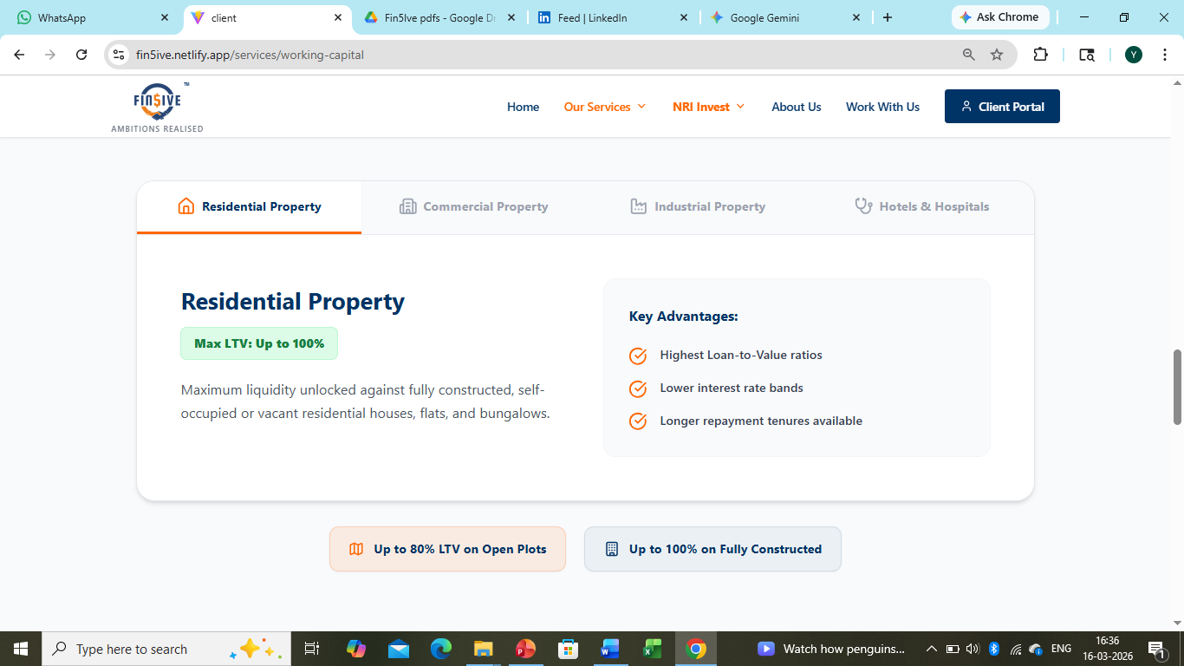

- Remove this 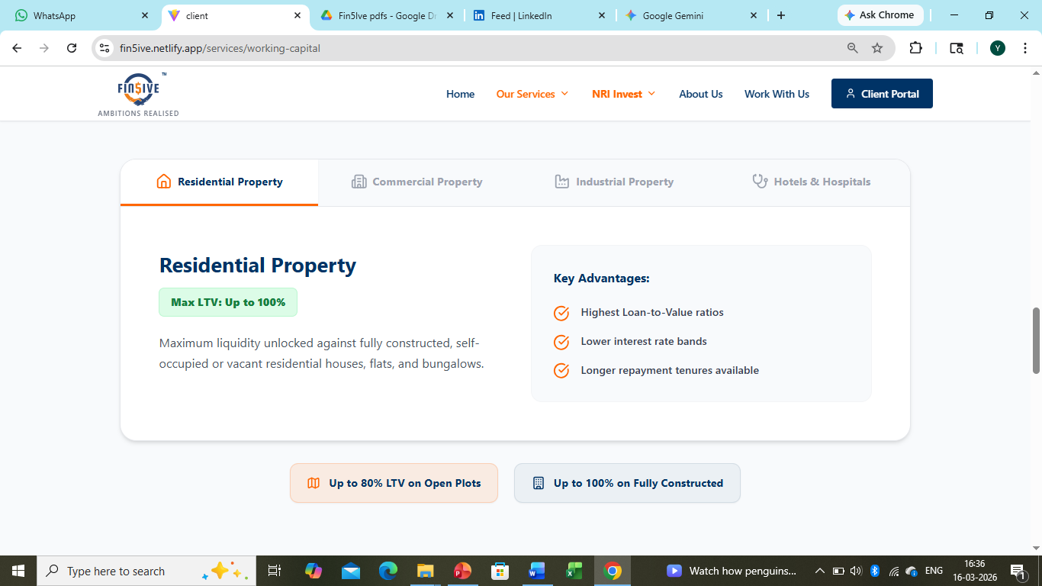
- Residential Property:- write Max LTV: Up to 90%
- Commercial Property:- write Max LTV: Up to 80%
- Industrial Property:- write Max LTV: Up to 80%
- Remove This

- Rename ZED Certification Page “ZED Certification and ISO Certification”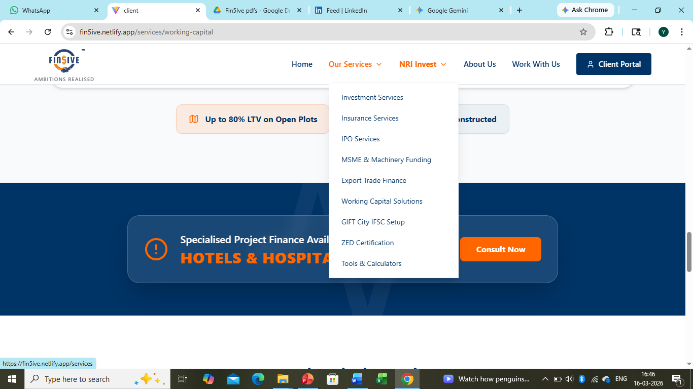
Also add this information under ISO certification section
ISO (International Organization for Standardization) certifications are globally recognized benchmarks that ensure organizations maintain the highest levels of quality, safety, efficiency, and sustainability. Achieving these certifications demonstrates a verified commitment to continuous improvement, strict regulatory compliance, and operational excellence.
FIN5IVE Management Private Limited operates in strict compliance with the following international standards:
ISO 9001: Quality Management Systems (QMS) ISO 9001 is the foremost international standard specifying requirements for a robust quality management system. This certification signifies a highly structured, process-driven approach to delivering financial advisory and management consulting services. It ensures that internal processes consistently meet both client requirements and statutory frameworks. The core principles of this standard include a strong customer focus, evidence-based decision-making, risk management, and continuous process improvement.
ISO 14001: Environmental Management Systems (EMS) ISO 14001 sets out the criteria for an effective environmental management system. It provides a strategic framework to identify, monitor, and control environmental impact. Holding this certification reflects a commitment to sustainable corporate practices, including efficient resource utilization, energy management, and proactive waste reduction. It ensures that business operations are conducted with a focus on long-term ecological responsibility and environmental compliance.
ISO 45001: Occupational Health and Safety Management Systems (OH&S) ISO 45001 is the global standard for occupational health and safety, providing a systematic framework to manage and mitigate workplace risks. This standard is focused on providing safe and healthy work environments by preventing work-related injury and ill health. It establishes that proactive measures are continuously implemented to eliminate hazards, minimize operational risks, and prioritize the overall safety and well-being of all personnel, partners, and stakeholders.

